Changes part 1
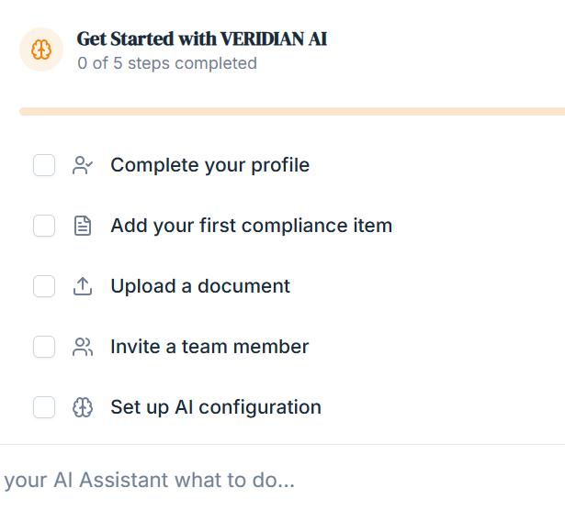
VERIDIAN AI is no longer a compliance tool.
don’t use first compliance Item. It has to be as per the user requirement.
Instead of Get Started with VERIDIAN AI it should be
This line stays - when opening the account by the user.
I am VERI, your assistant, you are my boss. Tell me about you, so that I can assist you better.
than flow has to be like a mode pills + options chain selector where user can select multiple roles he does.
It should flow easily, user need not type anything.
You should be able to map the person work, profile, gender, age, without user typing. It should be super simple.
after profile have all the connectors connected. So that while set up itself user is able to connect us with gmail etc.
Invite a team member should be on every screen in all the webpages on the upper right side in minimalist written in English with a + sign so that they can invite anyone.
Remove this
Set up AI configuration to be in settings. User will get confused.
Put it in settings
Remove it - Upload the document
Changes Part 2
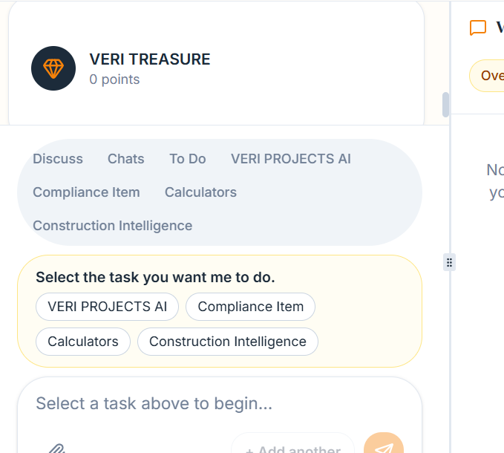
The options in Mode Pills and Chain Option Selector has to be as per the webpage user is on. For every module it will change automatically as per the module, for functionality it will change automatically as per the functionality. This is a very important feature. There has to be proper table for this permutation and combination. In system its already there. You need to ensure that it works properly. Without right option menu user cannot work. It’s a very important feature.
Changes 3
In the chat box, it should come
I am your Assistant VERI, select a task above to tell me what to do.
Changes 4
while creating account for the first time give option of signing with Google , like in most software, that should be the 1st option.
Than the 2nd option to be with email or magic link. If person puts email (manually) and submit than display should check your email, it has come from Supabase authentication. You need to click to authenticate.
also instead of password, make it 4 digit passcode, which will go to email.
The signing up process should be very fast and easy. Most small businesses use GMAIL.

